STUDY #31
THE TABERNACLE
Today we will study something special that God asked Moses to build: The Tabernacle … in the wilderness. Here are God’s words of instruction to build it: “Have them make a sanctuary for me, and I will dwell among them. Make this tabernacle and its furnishings exactly like the pattern I will show you.” (Exodus 25:8,9). God spoke to Moses and gave the “pattern” with all the details to be followed in building this Tabernacle. God was particular about the articles and his instructions were to be strictly followed: “ See that you make them according to the pattern shown you on the mountain” (Exodus 25:40). All the intricate details of this tabernacle and its coverings, curtains, walls, altars and the craftsmanship in metals is in Exodus chapters 25 through 39. Finally the day came when the tabernacle was complete: “Moses inspected the work and saw that they had done it just as the Lord had commanded. So Moses blessed them.” (Exodus 39:43).
This tabernacle or tent was to be set up in the middle of the encampment of Israel: “The Israelites are to camp around the Tent of Meeting some distance from it, each man under his standard with the banners of his family” (Numbers 2:2). The twelve tribes were to pitch their tents around it, on the four sides: north/south/east/west. We are going to see spiritual lessons in this structure because as we are told: “They [earthly priests] serve at a sanctuary that is a copy and shadow of what is in heaven” (Hebrews 8:5). The tabernacle was given by God as a picture of “heavenly things.”

The Tabernacle Courtyard
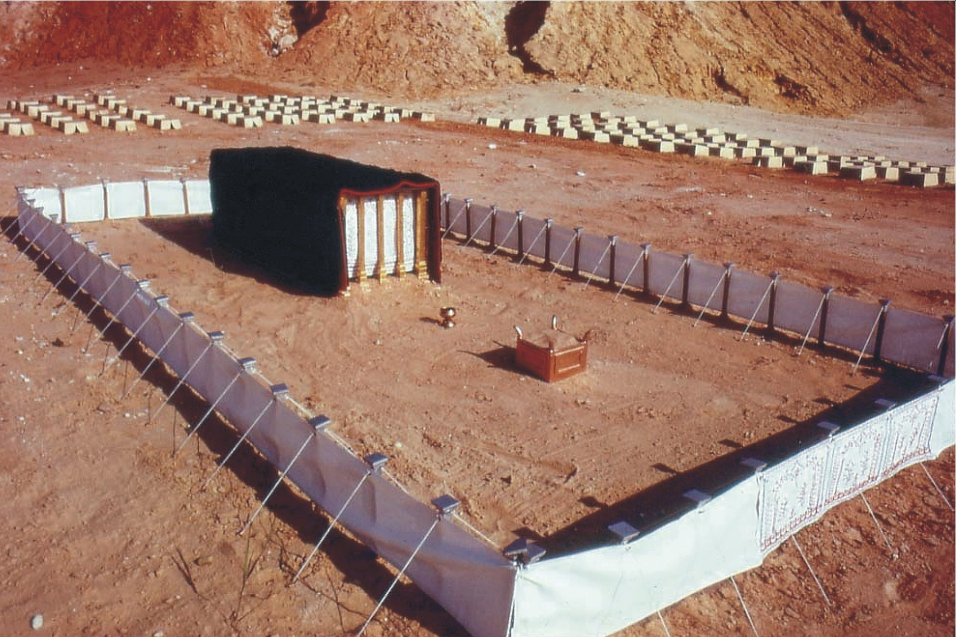
“Make a courtyard for the tabernacle. The south side shall be a hundred cubits long and is to have curtains of finely twisted linen, with twenty posts and twenty bronze bases and with silver hooks and bands on the posts. The north side shall also be a hundred cubits long and is to have curtains with twenty posts and twenty bronze bases and with silver hooks and bands on the posts. The west end of the courtyard shall be fifty cubits wide and have curtains with ten posts and ten bases. On the east end, toward the sunrise, the courtyard shall also be fifty cubits wide. Curtains fifteen cubits long are to be on one side of the entrance, with three posts and three bases, and curtains fifteen cubits long are to be on the other side, with three posts and three bases. For the entrance to the courtyard, provide a curtain twenty cubits long of blue, purple and scarlet yarn and finely twisted linen—the work of an embroiderer—with four posts and four bases. All the posts around the courtyard are to have silver bands and hooks, and bronze bases. The courtyard shall be a hundred cubits long and fifty cubits wide, with curtains of finely twisted linen five cubits high and with bronze bases.” (Exodus 27:9-18).
This outer curtain or wall was to be hung between pillars spaced five cubits apart. On the north and the south sides, the longer length of the tabernacle, there were twenty pillars; on the west and east sides of the tabernacle there were ten pillars each for a total of sixty pillars. The dimensions are given in the ancient unit called a cubit. One cubit is about one-and-a-half feet. So the north and south sides were one-hundred fifty feet long, the west and east sides were half that, seventy-five feet long.
This white “finely twisted linen” curtain was five cubits (seven-and-a-half feet) high, too high for a man to see over. The only one entrance to this courtyard was on the east side and was twenty cubits (thirty feet) wide; it was hung from five pillars. This entrance gate curtain was of “finely twisted linen” and embroidered in blue, scarlet, and purple. For someone standing on the outside, nothing could be seen except this curtain.
Since this Tabernacle was a copy or shadow of what is in heaven, studying it will make spiritual matters clearer to us. The Israelites in their camp, some distance from the tabernacle and on all four sides represented the whole world of mankind outside a knowledge of God. To the Israelites, the high curtain wall signified a barrier of unbelief: “The man without the Spirit does not accept the things that come from the Spirit of God for they are foolishness to him and he cannot understand them because they are spiritually discerned” (1 Corinthians 2:14). The man of the world—“the natural man”—cannot understand the spiritual things of God unless he receives God’s holy spirit which God has not yet “poured out on all flesh.” Thus the world remains in the “camp condition” of unbelief and blindness to the things of God.
Anyone who entered the courtyard had to approach the entrance curtain on the east side: “I am the gate, whoever enters through me will be saved” (John 10:9). The “gate” to the courtyard signifies Jesus Christ and it is only through faith in him that anyone can “enter” into the holy things of God. That is why Jesus said: “No one comes to the Father except through me” (John 14:6). Faith in Jesus is the only way back into a relationship with God.
The white linen of the curtain walls signify the holiness and the righteousness of Christ which, when one passes through, brings one within. Those white walls signify how a sinner, when he places his faith on Jesus, receives a “covering” for his sins, an imputed justification from his sins: “All the prophets testify about him that everyone who believes in him receives forgiveness of sin through his name” (Acts 10:43). Faith on Jesus brings the white covering to a sinner.
The one entering that “gate” notices that it is made up of four sections of five cubits each of “embroidered linen cloth.” Jesus is introduced to anybody only through the four gospels of Matthew, Mark, Luke, and John which bear the record of Jesus, his life and his death. The fifth pillar that holds up these four sections represents that in addition to the four evangelists there is another who bears great testimony in his fourteen letters comprising a third of the New Testament. The Apostle Paul too “holds up” the testimony of our Lord Jesus Christ. The colors of the yarn on this curtain signify the characteristics of the Lord Jesus. Scarlet represents the blood of the Ransom on the cross by which sacrifice he became the world’s saviour. Blue represents faithfulness as sky blue represents God’s faithfulness. Similarly Jesus is known as the faithful son of God. Purple represents royalty and Jesus is “The King of kings and the Lord of lords.” Purple is produced by mixing scarlet and blue. Similarly Jesus’ faithfulness to the heavenly Father’s will in becoming the world’s Savior by giving his life on the cross earned him the exaltation he both deserves and enjoys. This is the spiritual significance of the outer courtyard walls of the Tabernacle.
Those who enter by the “gate” into the courtyard first see an altar: “He set the altar of burnt offering at the entrance to the Tabernacle, the Tent of Meeting and offered on it burnt offerings and grain offerings as the Lord commanded him” (Exodus 40:29, with more details in Exodus 27: l-8). The altar of burnt offering was made of wood overlaid with copper or brass. It was five cubits square and three cubits high. It was a huge altar upon which animal sacrifices were offered.
Spiritually speaking after having shown faith on the Lord Jesus, the first thing that catches a believer’s attention is the awesome sacrifice of Jesus on the cross of Calvary. This altar of sacrifice represents that sacrifice. Between this altar and the main tent was a laver: “The Lord said to Moses, Make a bronze basin with its bronze stand for washing. Place it between the Tent of Meeting and the altar and put water in it. Aaron and his sons are to wash their hands and feet with water from it. Whenever they enter the Tent of Meeting they shall wash with water so that they will not die. Also when they approach the altar to minister by presenting an offering made to the Lord by fire, they shall wash their hands and feet so that they will not die. This is to be a lasting ordinance for Aaron and his descendants for the generations to come.” (Exodus 30:17-21). This laver (or basin of water) was between the brazen altar and the tabernacle tent in the courtyard. It was made of copper and the priests used the water within it to wash their hands and feet.
If Aaron (the High Priest) and his sons (the under-priests) failed to wash their hands and feet at this laver before any service at the altar or within the Tabernacle, they would die. We know a believer first notices the altar which symbolizes the sacrifice of Jesus Christ on the Cross of Calvary. Next the believer realizes he has learned this by reading the Bible, the Word of God. That is what the laver represents. The Bible is much like water as it begins to cleanse believers: “To make her holy, cleansing her by the washing with water through the word” (Ephesians 5:26). Just as water cleanses dirt on the hands and feet, so the reading of the Word causes a cleansing of actions (hands) and walk of life (feet). Worldly habits such as bad language, drinking, smoking, gambling, worldly movies, parties, and the like are to be washed away.
This courtyard represents the first stage of Christian development, the “called” stage: “Many are invited but few are chosen” (Matthew 22:14), or the condition of being merely “believers.” The altar of sacrifice and laver represent the faith upon Jesus’ sacrifice and the study of the Bible by a “believer.” The Levites represented these believers, those at the first stage of Christian development: “The Lord said to Moses, bring the tribe of Levi and present them to Aaron the priest, to assist him. They are to perform duties for him and for the whole community at the Tent of Meeting by doing the work of the tabernacle. They are to take care of all the furnishings of the Tent of Meeting , fulfilling the obligations of the Israelites who are to be given wholly to him. Appoint Aaron and his sons to serve as priests; anyone else who approaches the sanctuary will be put to death.” (Numbers 3:5-10). Only the priests were permitted to enter the sacred tent, the second stage of Christian development, the “chosen” stage of being “followers” of the Lord Jesus. These surrender their “will” to the Lord: “Then Jesus said to his disciples, If anyone would come after me he must take up his cross and follow me” (Matthew 16:24). These have entered into full consecration to do the will and service of God.

First Tent Compartment: The Holy
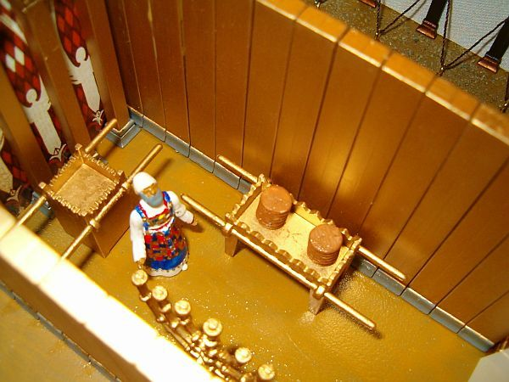
After passing the laver we stand in front of a curtain that leads into the Holy, the first of two compartments within this structure: “For the entrance to the tent, make a curtain of blue, purple and scarlet yarn and finely twisted linen—the work of an embroiderer. Make gold hooks for this curtain and five posts of acacia wood overlaid with gold. And cast five bronze bases for them.” (Exodus 26:36). This was the door to the Holy. Much like the entrance curtain of the courtyard, this hanging was embroidered in blue, scarlet, and purple. Levites were not permitted to enter this structure under penalty of death. Only the priests could do so.
Going under this curtain is the only way to leave the courtyard and enter the Holy. This pictures the way a believer becomes a follower, how the “called” become “chosen.” The process is called consecration, the making of a covenant by sacrifice: “Gather to me my consecrated ones, who have made a covenant with me by sacrifice” (Psalm 50:5). This is also the point where Christian baptism takes place, the “one Lord, one faith, one baptism” (Ephesians 4:5) which is the symbol of the secret covenant. “The Lord confides in those who fear him; he makes his covenant known to them” (Psalm 25:14). The symbol of this secret covenant by sacrifice is the one baptism of the Bible, where “death to the world” takes place: “Don’t you know that all of us who were baptized into Christ were baptized into his death?” (Romans 6:5). “For you died and your life is now hidden with Christ in God” (Colossians 3:3). This occurs by the surrender and denial of one’s will.
The Holy is a room ten cubits wide by twenty cubits long (fifteen feet by thirty feet). On the right side, the north side of the tabernacle, was the Table of Shewbread: “Take fine flour and bake twelve loaves of bread, using two-tenths of an ephah for each loaf. Set them in two rows, six in each row, on the table of pure gold before the Lord” (Leviticus 24:5,6). This table was of wood overlaid with gold; upon it were placed twelve cakes of unleavened bread in two piles or columns. Incense was placed on the top of each column: “Along each row put some pure incense as a memorial portion to represent the bread and to be an offering made to the Lord by fire” (Leviticus 24:7). This bread was holy and only priests were allowed to eat it: “This bread is to be set out before the Lord Sabbath after Sabbath, on behalf of the Israelites as an everlasting covenant. It belongs to Aaron and his sons who are to eat it in a holy place because it is a most holy part of their regular share of the offerings made to the Lord by fire” (Leviticus 24:8,9).
The shewbread in its peculiar arrangement of two columns of six cakes each represents the spiritual bread of the Christian, the Word of God, the Bible, with its sixty-six books. This was food only for priests which represents that the spiritual truths of the Bible can be understood or “digested” only by the consecrated followers of Christ, the “chosen” class among Christians who have become priests by “presenting their bodies as living sacrifices.” The unleavened bread represents the pure truth. The renewal of this bread every Sabbath could represent the spiritual feeding and the new truths received every Sunday in worship service and in the meetings of consecrated church members.
On the left side of the Holy was a lamp stand: “They made the lamp stand of pure gold and hammered it out, base and shaft; its flowerlike cups, buds and blossoms were of one piece with it. Six branches extended from the sides of the lamp stand—three on one side and three on the other. Three cups shaped like almond flowers with buds and blossoms were on one branch and the same for all six branches extending from the lamp stand. And on the lamp stand were four cups shaped like almond flowers with buds and blossoms. One bud was under the first pair of branches extending from the lamp stand, a second bud under the second pair and a third bud under the third pair—six branches in all. The buds and the branches were all of one piece with the lamp stand hammered out of pure gold. They made its seven lamps as well as its wick trimmers and trays of pure gold. They made the lamp stand and all its accessories from one talent of pure gold.” (Exodus 37:17-24).
The making of the golden lamp stand out of pure gold and beaten work is described in detail. It had seven branches and at the end of each branch was a lamp. These seven lamps provided the only light in the Holy since the many coverings and the curtains over the Tabernacle kept out all natural light. These seven branches had peculiar workmanship; its bowls were shaped like almonds and its design alternated fruit and flower. These seven lamps were cared for, trimmed, and supplied with oil by the high priest himself. The light from the lamp stand was under his care.
This lamp stand shows that for a Christian in the holy or consecrated condition of being “chosen” as a follower of the Master, their light is special: “You are a chosen people, a royal priesthood, a people belonging to God, that you may declare the praises of him who called you out of darkness into his wonderful light” (1 Peter 2:9). The oil in the lamps represents the holy spirit and the light shed forth is the enlightenment of the truth: “We have not received the spirit of the world but the Spirit who is from God that we may understand what God has freely given us. This is what we speak not in words taught us by human wisdom but in words taught by the Spirit expressing spiritual truths in spiritual words.” (1 Corinthians 2:12,13). “When the spirit of Truth comes, he will guide you into all truth. He will not speak on his own he will speak only what he hears and he will tell you what is yet to come.” (John 16:13).
This light is the understanding of prophecy, of “things to come,” and the deeper understanding of the marvelous divine plan of God, “here a little and there a little” in words, symbols, types, and parabolic language. These truths cannot be understood by mere “believers.” Christians who are not permitted to see the light of the Holy are like the Levites who were not allowed to enter into that room. The high priest who watches over and cares for the lamps on the lamp stand represents the Lord Jesus as the great high priest and head of the church who personally supervises all the light of Truth: “In the midst of the lamp stands was someone like a son of man dressed in a robe reaching down to his feet and with a golden sash around his chest” (Revelation 1:13). The seven branches of the lamp stand represent the great truth of the seven churches which we read about in Revelation chapters two and three. The peculiar workmanship of beaten work with a fruit and a flower represents the building up of the church’s character, “strengthening the disciples and encouraging them to remain true to the faith. We must go through many hardships to enter the Kingdom of God” (Acts 14:22). The character of the church is developed through tribulation or “beaten work” but the developed character is like a fruit and a flower; from God’s viewpoint it is both beautiful and fruitful from beginning to end.
Opposite the entrance curtain to the Holy near the back wall was the Golden Altar, also called the Incense Altar: “Moses placed the gold altar in the Tent of Meeting in front of the curtain and burned fragrant incense on it as the Lord commanded him” (Exodus 40:26,27). This small altar was made of wood overlaid with gold. The priest put hot coals in a censor, placed the censor upon the top of this altar, and then dropped incense upon it producing a fragrance along with smoke.
For the consecrated or “chosen,” those who follow in Jesus’ footsteps, this third item of furniture inside the Holy represents their daily sacrifice. The “handful” of incense shows each individual’s capacity, some large, some small. Each one’s capacity to sacrifice varies according to one’s talents. God does not expect from us what we do not possess; he does expect a willingness to give all that we do have. The coals represent the hostile world and contact with it causes fiery experiences of opposition. These burning experiences bring forth perfumed smoke which represents the desire by consecrated Christians to “live a life of love just as Christ loved us and gave himself up for us as a fragrant offering and sacrifice to God” (Ephesians 5:2). The perfumed fragrance and smoke represents the character and walk of life that is manifested, the “fruit of the Spirit” which fills the Holy and is seen and appreciated by “fellow priests” or brethren.

Second Tent Compartment: The Most Holy
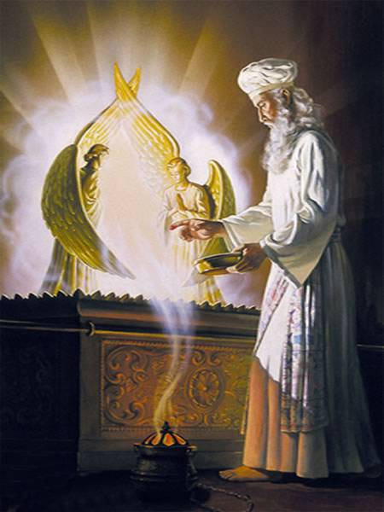
Finally we come to the curtain leading into the Most Holy: “Make a curtain of blue, purple and scarlet yarn and finely twisted linen with cherubim worked into it by a skilled craftsman. Hang it with gold hooks on four posts of acacia wood overlaid with gold and standing on four silver bases. Hang the curtain from the clasps and place the ark of the Testimony behind the curtain. The curtain will separate the Holy place from the Most Holy place.” (Exodus 26:31-33). This curtain was the second one within the main tent and separated the Holy from the Most Holy. It was the only way to enter the Most Holy and only the High Priest would enter once a year on the Atonement Day bearing the blood of sacrifice to apply on the Mercy Seat. This curtain was visible only to the priests within the Holy who beheld the designs of the cherubims in blue, purple, and scarlet. A much thicker, heavier curtain tore in the temple when Jesus died: “At that moment the curtain of the temple was torn in two from top to bottom. The earth shook and the rocks split.” (Matthew 27:51). “The sun stopped shining and the curtain of the temple was torn in two” (Luke 23:45). If the high priest did not fulfill all the necessary regulations before entering, he would die.
As we seek to understand the symbolism, we note that all three curtains—the one into the courtyard, the one into the Holy, and the one into the Most Holy—were all made of blue, purple, and scarlet thread, colors that represent the characteristics of Jesus: blue a symbol of faithfulness; purple a symbol of royalty; scarlet a symbol of the blood of the ransom and Jesus being the Saviour of the world. Finely twisted linen symbolizes the Lord’s righteousness: “holy, undefiled, separate from sinners.” Jesus said of himself: “I am the way and the truth and the life. No one comes to the Father except through me.” (John 14:6). Those are the three curtains. It is Jesus who leads and guides the Christian at every step in the development process. First as a believer (the gate into the courtyard), then as a follower (the curtain into the Holy), and finally into heavenly life in the First Resurrection (the curtain into the Most Holy). Speaking of this heavenly resurrection Jesus said: “No one can come to me unless the Father who sent me draws him and I will raise him up at the last day” (John 14:6). What a wonderful representation of the words of the Saviour: “Surely I will be with you always to the very end of the age” (Matthew 28:20).
The curtain leading into the Most Holy pictures the death of the human body since in heaven, pictured by the Most Holy, “flesh and blood” cannot live: “I declare to you brothers that flesh and blood cannot inherit the kingdom of God. Listen, I tell you a mystery; we will not all sleep but we will all be changed.” (1 Corinthians 15:50,51). To enter the Most Holy one must receive a spirit body which occurs after a Christian dies, then is resurrected.
The cherubim embroidered on this curtain can be seen only by the priests when they serve in the Holy. This shows that when the consecrated face the trials of their Christian walk, they behold these cherubim. In Revelation chapter 4 there are four living creatures and these correspond to God’s character attributes the first of which is love. Jesus described God’s great love for his followers: “The Father himself loves you because you have loved me and have believed that I came from God” (John 16:27). The second attribute of great encouragement is power. When trials and tribulations mount on all sides, a knowledge of God’s power comes to mind as we remember: “If God is for us, who can be against us?” (Romans 8:31). Nothing can be against us in the entire universe. God’s love and power greatly encourages and strengthens Christians to faithfulness in all their experiences.
After we pass this third and final curtain we are in the innermost chamber of the tabernacle, the Most Holy. It was also called the “Holy of Holies” and was ten cubits in height, length, and breadth—a perfect cube. The only item of furniture in this room was the Ark of the Covenant: “Behind the second curtain was a room called the Most Holy place, which had the … gold covered ark of the covenant. This ark contained the gold jar of manna, Aaron’s rod that had budded, and the stone tables of the covenant. Above the ark were the cherubim of the Glory, overshadowing the place of atonement” (Hebrews 9:3-5). “Bezalel made the ark of acacia wood, two-and-a-half cubits long, a cubit and a half wide and a cubit and a half high. He overlaid it with pure gold both inside and out and made a gold molding around it. He made four gold rings for it and fastened them to its four feet with two rings on one side and two rings on the other. Then he made poles of acacia wood and overlaid them with gold. And he inserted the poles into the rings on the sides of the ark to carry it. He made the atonement cover of pure gold—two and a half cubits long and a cubit and a half wide. Then he made two cherubim of hammered gold at the ends of the cover. He made one cherub on one end and the second cherub on the other; at the two ends he made them of one piece with the cover. The cherubim had their wings spread upward, overshadowing the cover with them. The cherubim faced each other, looking toward the cover.” (Exodus 37:1-9).
The Ark of the Covenant was a rectangular box with a lid or cover which was of pure gold and from that same gold was formed two cherubims of gold. They looked at a point in the center of the lid called the “Propitiatory” or “Mercy Seat.” Both cherubims had their wings spread upward as if ready to fly. It was upon the Mercy Seat that the high priest sprinkled the blood of the atonement day sin offering sacrifices. Within this Ark, inside the box, was: 1) a gold jar of manna; 2) Aaron’s rod that budded; 3) the stone tablets of the law.
Regarding the golden jar of manna: “Moses said, This is what the Lord has commanded, take an omer of manna and keep it for the generations to come so they can see the bread I gave you to eat in the desert when I brought you out of Egypt. So Moses said to Aaron, Take a jar and put an omer of manna in it. Then place it before the Lord to be kept for the generations to come. As the Lord commanded Moses, Aaron put the manna in front of the Testimony that it might be kept.” (Exodus 16:32-24).
Regarding Aaron’s rod that budded: “The next day Moses entered the Tent of the Testimony and saw that Aaron’s staff, which represented the house of Levi had not only sprouted but had budded, blossomed and produced almonds” (Numbers 17:8). It was subsequently placed in the ark as perpetual testimony that God had selected Aaron and the house of Levi as his special ministers.
Regarding the two stone tables of the Law: “Take this book of the Law and place it beside the Ark of the Covenant of the Lord your God” (Deuteronomy 31:26).
Between the two cherubim on the cover of the ark glowed a supernatural light called the shekinah in the Hebrew language. It was the only light in the Most Holy. As we have seen the Most Holy is a representation of heaven itself, the final condition of the Church of Jesus Christ, with Jesus and God in glory. The Ark of the Covenant is a glorious representation of the invisible God of the universe, our heavenly Father, and how we comprehend him through his divine attributes. The Mercy Seat received the blood sprinkled upon it by the high priest every year on the Day of Atonement. Thus the mercy seat represents God’s justice. Blood represents life: “For the life of a creature is in the blood and I have given it to you to make atonement for yourselves on the altar; it is the blood that makes atonement for one’s life” (Leviticus 17:11). The blood represented the satisfaction of justice: a life for a life.
The box itself with the supernatural light above it represents God’s attribute of wisdom. God’s wisdom is personified in Jesus: “It is because of him that you are in Christ Jesus, who has become for us wisdom from God—that is our righteousness, holiness and redemption” (1 Corinthians 1:30). The three items contained in the box represent the attributes of The Christ, Jesus as head and the church his body members. Aaron’s rod that budded shows The Christ as the chosen “royal priesthood” of God: “You are a priest forever in the order of Melchizedek” (Hebrews 5:6). The church is included: “But you are a chosen people, a royal priesthood, a holy nation, a people belonging to God, that you may declare the praises of him who called you out of darkness into his wonderful light” (1 Peter 2:9).
The tablets of the Law shows that Christ is the appointed judge and law executor of God: “For he has set a day when he will judge the world with justice by the man he has appointed. He has given proof of this to all men by raising him from the dead.” (Acts 17:31). The church is included: “Do you not know that the saints will judge the world?” (1 Corinthians 6:2). The golden pot contained incorruptible manna quite unlike the manna that the Israelites gathered each day and which became corrupt by the second day. This special incorruptible manna represents incorruptible, immortal life, the divine nature. Concerning Jesus: “I am the living one. I was dead, and behold I am alive for ever and ever. And I hold the keys of death and Hades.” (Revelation 1:18). The church is included: “Through these he has given us his very great and precious promises, so that through them you may participate in the divine nature and escape the corruption in the world caused by evil desires” (2 Peter 1:4).
The two cherubims represent the remaining two attributes of God, love and power. They are shown looking at the Mercy Seat because until the atonement work of the sacrifices of The Christ are complete, God’s love and power cannot be manifest to the world. When justice is finally satisfied, God’s love and power will quickly usher in the kingdom blessings of resurrection and restitution for the whole world of mankind. The supernatural light also shows the divine presence of the heavenly Father: “This is the message we have heard from him and declare to you: God is light; in him there is no darkness at all” (1 John 1:5).
Thus the entire “Ark” represents the oneness of the divine family as Jesus beautifully put it: “That all of them may be one, Father, just as you are in me and I am in you. May they also be in us so that the world may believe that you have sent me” (John 17:21). To this we respond in awestruck wonder,
—Amen—

All Scripture quotations are from the New International Version of the Bible unless otherwise identified.

