STUDY #1
THE KEYS TO UNLOCK THE BIBLE
Today we look into the subject of the Holy Scriptures, the Bible, and how to study and understand it. It is NOT an easy book to understand as all would readily admit! In fact hardly any can really confess to know and fully understand the Bible!
Let us begin our study today by seeing what does the word “ Bible” mean? It comes from the Greek word biblos which means book! Whose book? God’s book! So simple and yet so powerful! God wrote a book which are his words to all mankind!
The world has many books called holy books from the various gods of the various religions. The Hindu Holy Books are called the Vedas: Rig Veda, Yajur Veda, Sama Veda and Atharva Veda. But the Bible in Indian languages is called Sathya Veda or the “Veda of Truth.”
Before we go into the keys to unlock and understand the Bible, let us first study some facts and details about its composition.

“The keys to unlock the Bible”
There are two divisions to the Holy Scriptures: the Old Testament (before Jesus) and the New Testament (after Jesus). The Old Testament contains 39 Books while the New Testament contains 27, a total of 66 Books. It is a Book of Books!
Some Christians, like our Roman Catholic friends, think there are more than 66 books to the Bible! Rather than argue who is right, let us turn to the Word of God itself for the answer. In Leviticus 24:5-7 the “bread of presence” in the “holy” of the Tabernacle is in two stacks of six round, flat loaves each. The six and six represent the 66 Books of the “spiritual bread” from God!
The first five Books of the Old Testament are called the Pentateuch and were written by Moses. The Jews call it the Torah and it is sacred to them because it is the Law from God!
This Bible took an unbelievable 1,700 years to be written. The Old Testament took 1,600 years and the New Testament 100 years. No other book in this world can boast of such a long period for its composition! The Book of Job was the first book to be written and the book of Revelation was the last to be written in 96 A.D. A total of forty authors were used by God as his instruments from different and varying backgrounds to record his Word:
LUKE was a doctor.(Colossians 4:14)
MATTHEW was a Tax Collector.(Luke 5:27,28)
DAVID was a Shepherd and later become a king (1 Samuel 16:19)
SOLOMON was a King. (1Kings 2:12)
MOSES was highly educated and was being trained to be the next Pharaoh of Egypt. (Exodus 2:10)
PAUL was a Pharisee. (Acts 23:6)
AMOS was a poor shepherd. (Amos 7:14)
PETER was a fisherman as was also JOHN, etc. (Matthew 4:18-21)
The most wonderful and unbelievable thing about the Bible is that it is totally in harmony and without any contradiction at all. Thus we come to understand that the real author is God himself using human instrumentalities as we read and confirm this in the Bible:
“God, who at sundry times and in divers manners spake in time past unto the fathers by the prophets, hath in these last days spoken unto us by his Son, whom he hath appointed heir of all things, by whom also he made the worlds” (Hebrews 1:1,2).
“All scripture is given by inspiration of God,and is profitable for doctrine, for reproof, for correction, for instruction in righteousness” (2 Timothy 3:16).
Among so many books in this world the Bible is the most read book with even non-Christian leaders like Mahatma Gandhi, Jawaharlal Nehru, and the Dalai Lama reading it. The fact is that India’s independence was gained through the Bible. Mahatma Gandhi, the “father of the nation” of India, was greatly influenced by the Bible. He was specially touched by these words: “But I say unto you, that ye resist not evil: but whosoever shall smite thee on thy right cheek, turn to him the other also” (Matthew 5:39).
It became the basis of the “non-violent” or “Ahimsa Movement” through which India became independent. Even today these words are found in the Indian Parliament house, but few know it is from the Bible. They all think it is Mahatma Gandhi’s words.
The Bible is also the most printed book, with the first printed page from a printing press being from the Bible in the year 1454 A.D. It is now printed in more than two thousand languages of the world.
But with all this the Bible is also the most misunderstood book with its language and symbols greatly misunderstood by even a great majority of Christians themselves.
Yes, the Bible is spiritual food from God to man as we read:
“He answered and said, It is written, Man shall not live by bread alone, but by every word that proceedeth out of the mouth of God” (Matthew 4:4).
“That he might make thee know that man doth not live by bread only, but by every word that proceedeth out of the mouth of the LORD doth man live” (Deuteronomy 8:3).
“Thy words were found, and I did eat them; and thy word was unto me the joy and rejoicing of mine heart” (Jeremiah 15:16).
And just as natural food is varied in nature and the nutrition is suited to the different stages of development, so too it is with spiritual food as we read in this text: “For when for the time ye ought to be teachers, ye have need that one teach you again which be the first principles of the oracles of God; and are become such as have need of milk, and not of strong meat. For every one that useth milk is unskillful in the word of righteousness: for he is a babe. But strong meat belongeth to them that are of full age, even those who by reason of use have their senses exercised to discern both good and evil.” (Hebrews 5:12-14).
Here the apostle Paul shows clearly the varied spiritual food: “milk” and “solid food.” Just as growing babies move from only milk to solid food, so too must be the spiritual progress and growth. But as the apostle says, many are found to have no growth at all since he says: “For when for the time ye ought to be teachers, ye have need that one teach you again which be the first principles of the oracles of God.”
What is meant by “milk”? We find the answer in the next chapter: “Therefore leaving the principles of the doctrine of Christ, let us go on unto perfection; not laying again the foundation of repentance from dead works, and of faith toward God, Of the doctrine of baptisms, and of laying on of hands, and of resurrection of the dead, and of eternal judgment. And this will we do, if God permit.” (Hebrews 6:1-3).
All the elementary basic doctrinal teachings are the “milk” of God’s word. This is further expressed by the apostle Peter as well: “As newborn babes, desire the sincere milk of the word, that ye may grow thereby” (1 Peter 2:2). All spiritual growth must begin with “milk” as with natural growth.
Now let us come to the important question of how to study the Bible. It is such a difficult book to understand because it seems to be a locked book. Surely there must be keys to unlock the Bible. What are they? By God’s grace today we are going to see the three “golden keys” to unlock the Bible. The “gold” here represents that which is divine as these “keys” are of God.

Golden Key #1
“For precept must be upon precept, precept upon precept; line upon line, line upon line; here a little and there a little” (Isaiah 28:10). Most people do not understand what this verse means. To better understand it we must examine its context in the previous verse: “Whom shall he teach knowledge? and whom shall he make to understand doctrine?”
Context is how to study and understand the teachings or doctrines of the Bible. This is the “first golden key” when studying the Scriptures: “Precept upon precept” (and “rule upon rule”). “Precept” means teachings or subjects and “rule” means verses.
There is to be a proper systematic order of the study of teachings (or subjects) and the subjects themselves have an order of verses (“rule”). But note the last words: “here a little and there a little.” The verses required for study are scattered in the Bible: “here a little and there a little.”
Let us take an example. The Bible speaks of a man who never died. His name is Enoch. The story of Enoch is found in three verses only and they are in Genesis 5:24, then Hebrews 11:5, and then Jude 14. This is the principle of “here a little and there a little.”
Why is the phrase repeated twice: “precept upon precept, precept upon precept; line upon line, line upon line”? As we have already seen the word “precept” refers to teachings or subjects and the word “rule” refers to verses. The mentioning of the matter twice refers to the fact that all Bible study must involve the two parts of God’s word: The Old Testament and the New Testament.
Why are the verses scattered--“here a little and there a little”--in the Bible? Here is the answer: “And he hath cast the lot for them, and his hand hath divided it unto them by line; they shall possess it for ever, from generation to generation shall they dwell therein” (Isaiah 34:17).
In what way would God cast a “lot” for his truth? When casting “lots,” paper was torn into pieces and the names of people involved in that “lot” were written on the pieces, and finally the “lot” was cast! Similarly God for each of his doctrines and teachings of truth has divided them into “pieces” or “verses.” God himself has divided the truth “by line,” through verses, and then God has taken the various verses and hidden and distributed these throughout the 66 Books of the Bible! This is the divine system of locking truth.
Why does God lock the truth? He does it because it is precious and not to be dishonored and misused. Likewise mankind stores and locks their precious valuables in safes and complicated lockers. Much more precious are the truths of God! Thus we see the Bible is a “locked” and “coded” book. How then do we open it? We read of the answer in Isaiah: “Seek ye out of the book of the LORD, and read: no one of these shall fail, none shall want its mate: for my mouth it hath commanded, and his spirit it hath gathered them” (Isaiah 34:16).
One needs to search and seek in the Word of God for those verses. Every verse has “its mate” which refers to its pair. Thus “male” and “female” are a pair, as also in electrical wiring a “positive” and “negative” wire are a pair. Every verse of question has a corresponding or answering verse. The Bible answers every question in it. But one needs God’s spirit to “gather” or find them and the order (John 16:13). There needs to be a systematic study of subjects with the verses scattered in all the sixty-six books of the Bible.
Before we go to the second “Golden Key” concerning how to study the Bible, let us look at two verses in Isaiah: “For precept must be upon precept, precept upon precept; line upon line, line upon line; here a little and there a little” (Isaiah 28:10). “But the word of the LORD was unto them precept upon precept, precept upon precept; line upon line, line upon line; here a little, and there a little; that they might go, and fall backward, and be broken, and snared, and taken” (Isaiah 28:13).
Notice the similarity in language and yet the great difference in these two verses. Bible study may take you backward in knowledge or cause one to lose the way of truth. The phrase “be broken and snared and taken” means getting caught in false doctrines and errors of untruth! So how do we know what is truth? The answer is in John 17:17: “Thy word is truth.”
How does one know what is right Bible study? By testing the doctrinal beliefs taught. Are they according to the scriptures? Here is a Scriptural example: “Can a soul die in hell”? Most people say, No! But we teach a soul CAN die in hell because we read this in the Bible: “Fear not them which kill the body, but are not able to kill the soul: but rather fear him which is able to destroy both soul and body in hell” (Matthew 10:28).
The Bible teaches that the soul can die in hell. It also says the body goes to hell! Surprised? We will be studying about the human soul in great detail in future classes!
So always test whether what you learn from your Bible class has a Scriptural basis. The Bible itself warns of false teaching and false Bible studies.

Golden Key #2
“Study to shew thyself approved unto God, a workman that needeth not to be ashamed, rightly dividing the word of truth” (2 Timothy 2:15).
Written language has many forms such as poetical, dramatic, prose, etc. So too the Bible has been written by God using three forms of language: Literal, Parabolic, and Symbolic. We need to identify the form of language being used in the words being studied.

Literal Language
“In the beginning God created the heaven and the earth” (Genesis 1:1).
“And she shall bring forth a son, and thou shalt call his name Jesus: for he shall save his people from their sins” (Matthew 1:21).
Much of the Bible is written in easily understood, literal language. But let us remember that the entire Bible is NOT written only in literal language.

Parabolic Language
Parables are “little stories” that are not to be taken literally but spiritually. They have a spiritual meaning or significance behind them. Consider this popular parable recorded in Luke: “And he spake this parable unto them, saying, What man of you, having an hundred sheep, if he lose one of them, doth not leave the ninety and nine in the wilderness, and go after that which is lost, until he find it? And when he hath found it, he layeth it on his shoulders, rejoicing. And when he cometh home, he calleth together his friends and neighbours, saying unto them, Rejoice with me; for I have found my sheep which was lost. I say unto you, that likewise joy shall be in heaven over one sinner that repenteth, more than over ninety and nine just persons, which need no repentance.” (Luke 15:3-7)
This parable is usually read at the baptism of a newcomer to Christianity. New converts are thought to be “lost sheep.” Many think verse 7 refers to individual sinners and their repentance and turning to God. This verse says: “I say unto you, that likewise joy shall be in heaven over one sinner that repenteth more than over ninety and nine just persons that need no repentance.”
If this refers to individual, repenting sinners, who are the “ninety nine just persons” who need no repentance? Are there that many “just persons” in this world? “As it is written, There is none righteous, no, not one” (Romans 3:10). Regarding all mankind none are just! So who are these 99 “just persons”?
This parable does not refer to individual sinners at all. Jesus is speaking of a certain man having 100 sheep. Wealth in those days was calculated in terms of sheep, cattle, camels etc. This is a picture where God is the owner and creator of all creation; he is referred to as a “shepherd” (Psalm 23:1). Who are God’s sheep? “Sheep” is a symbol of the various obedient creations of God. The number 100 refers to the various species within creation: animals, birds, fish, insects, plants, angels, cherubim, man, etc. The number 100 is only a picture of all creation since we can be sure all creation far outnumbers 100!
Of all God’s creations, only one “sheep” or species was “lost” and that was mankind. As a race they are lost to sin and its wages which is death (Romans 6:23). So God sent his only begotten son Jesus to search for that “lost sheep,” the lost race of mankind, as we read: “ For God so loved the world, that he gave his only begotten Son” (John 3:16). And at the end there will be great rejoicing in heaven when mankind is delivered from the condemnation of sin and death and given everlasting life.

Symbolic Language
This is language where symbols are used to hide the meaning of great prophecies. The Book of Revelation is full of symbols: “He sent and signified it by his angel unto his servant John” (Revelation 1:1). This kind of language is also found in many other books of the Bible such as Ezekiel, Daniel, etc.
Symbols in nature like wind, water, hill, mountain, city, clouds, trees, grass, horns, fire, etc. are used and each have their meanings found right in the Bible itself. Consider the word “leaven” in Matthew 16:6. What does it mean? The Bible gives us the answer: “Then understood they how that he bade them not beware of the leaven of bread, but of the doctrine of the Pharisees and of the Sadducees” (Matthew 16:12). The doctrines of the Pharisees and the Sadducees were false doctrines: “For the Sadducees say that there is no resurrection, neither angel, nor spirit” (Acts 23:8). Thus “leaven” is, as the Lord tells us, a symbol for false doctrines and false teachings.
Let us study one full verse of symbolic language in Ecclesiastes 11:1: “ Cast thy bread upon the waters: for thou shalt find it after many days.” Is this literal language? If you put bread in water, it dissolves almost immediately, leaving no residue! How can you find it “after many days”? This is symbolic language! The three symbols are: 1) “bread”, 2) “waters”, 3) “after many days.” Now let us discover their meanings.
Bread refers to the word of God, the “spiritual” bread (see Jeremiah 15:16 and Matthew 4:4). Waters refers to the world of “peoples, and multitudes, and nations and tongues” (see Revelation 17:15). After many days refers to the period of the kingdom of God on earth when all the people will repent and turn to God: “All the ends of the world shall remember and turn unto the LORD: and all the kindreds of the nations shall worship before thee. For the kingdom is the LORD’s: and he is the governor among the nations” (Psalm 22:27,28).
Thus casting bread upon waters speaks of witnessing the truth now before the people without expecting any immediate results, but rather in the future. Thus one must “rightly divide the word of truth,” or correctly identify and understand the language form used, to gain the truth. When symbolic language is used, one must not take it as literal language; and when literal language is being used, one must not take it symbolically.

Golden Key #3
The third “key” to Bible study is a topical study of various subjects by searching for the verses on those subjects: “here a little and there a little” in the Bible. Consider the subjects of Soul, Salvation, Baptism, Church, etc. You may wonder how all Scriptures relating to specific words in the Bible can be identified and found. It is a gigantic task! But God’s grace is upon Christians in these last days. To assist in finding the various verses on specific subjects today we have concordances in which are listed all verses corresponding to various words. The two most reliable concordances are written by Dr. Young and Dr. Strong.
Thus a mere reading of the Bible from Genesis to Revelation, from chapter to chapter, will not really help you find the truth for it is “here a little and there a little.” Thus by following this method a fruitful and blessed study can be made of various subjects in the Bible and one can gain the truth from God’s word.
Having understood these “three golden keys” to Bible study, let us finally study a few examples how the Word of God is symbolized.
“Is not my word like a fire? saith the LORD; and like a hammer that breaketh the rock in pieces?” (Jeremiah 23:29). God’s word is compared to “fire” and “hammer.” Fire both destroys and purifies especially when used to purify metals from impurities. So too, the word of God, like fire, destroys sin and purifies the heart from every sin and impurity. The “hammer” refers to a large and strong rock hammer used to break large stones. The word of God is like a great hammer that breaks and sets free hearts that are as hard as stone in sin and selfishness.
The symbol is “light” in Psalm 119:105: “Thy word is a lamp unto my feet, and a light unto my path.” We can better understand this symbol if we read from Isaiah: “For behold, the darkness shall cover the earth, and gross darkness the people” (Isaiah 60:2). This is not literal “darkness” but symbolic darkness! The whole world and its people are said to be covered “in darkness.” The meaning of this “darkness” is understood when contrasted with the symbol of “light.” The “light” of God’s Word is the truth (John 17:17) and “darkness” signifies untruth. The Word of God is the “light” (truth) in a world full of “darkness” (untruth).
The symbol “sword” is used in Ephesians 6:17: “The sword of the spirit, which is the word of God.” God’s word is symbolized by a sword which is normally a weapon of warfare, but here its meaning is spiritual. The word of God is the weapon for spiritual warfare against wickedness and evil: “For the word of God is quick, and powerful, and sharper than any twoedged sword” (Hebrews 4:12). The sharp edges on both sides symbolize how the truth of God’s word affects both the hearers and the speaker.
Finally we read of the symbol “food”: “That he might make thee know that man doth not live by bread only, but by every word that proceedeth out of the mouth of the Lord” (Deuteronomy 8:3). Here the Word of God is symbolized as “food.” It is the spiritual food for “life” and “growth” for mankind as they proceed toward and gain understanding regarding how to gain eternal life.
We conclude with these words: “All scripture is given by inspiration of God, and is profitable for doctrine, for reproof, for correction, for instruction in righteousness: that the man of God may be perfect, thoroughly furnished unto all good works” (2 Timothy 3:16,17). A proper and complete knowledge of all the truths is essential in the service of God. It is necessary to pay careful attention to this Scripture and study the Scriptures correctly to be men and women of God. Today we have taken the first step in that direction!
Amen!
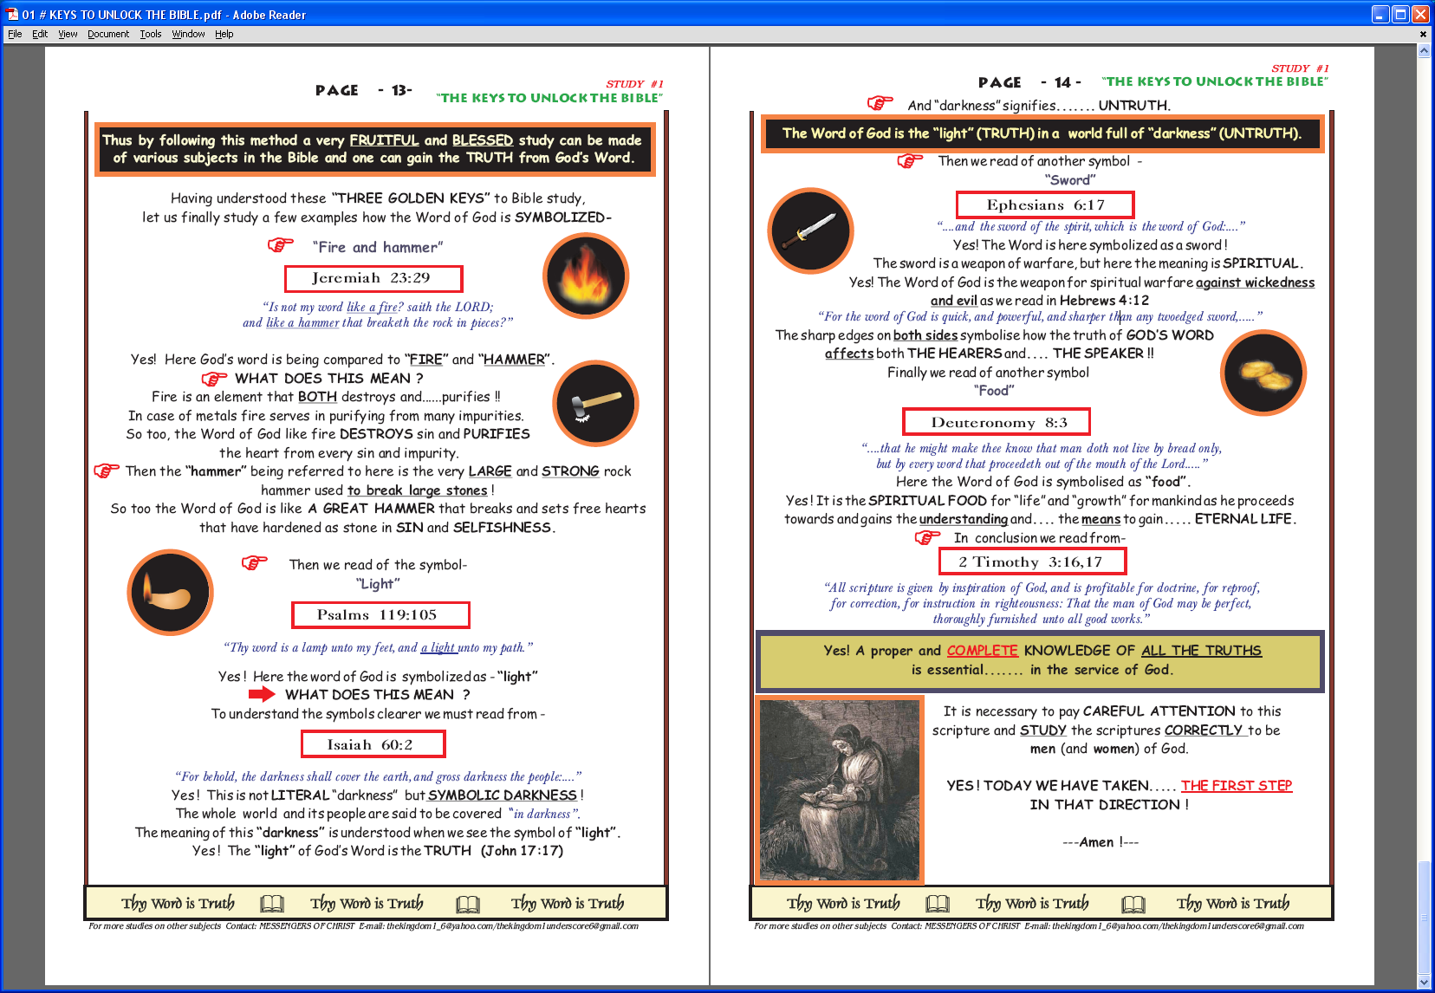

Kindly refer to your Bibles for every Scripture reference and read thoroughly. Most Scripture passages are quoted from the authorized King James Version (KJV).

